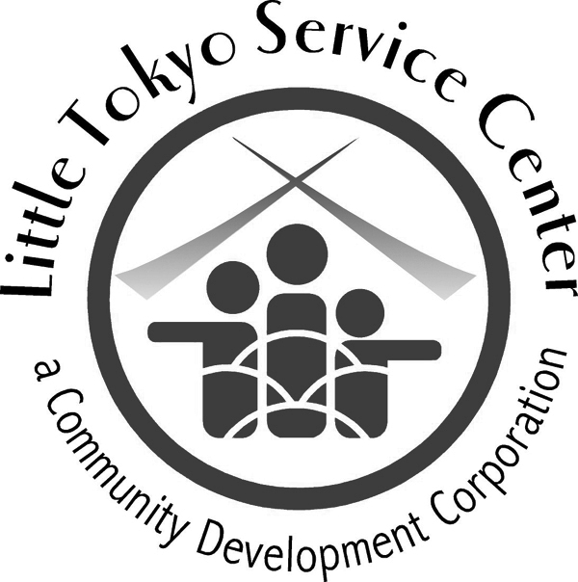

The Little Tokyo Service Center (LTSC) is looking for a strong communicator and outgoing person to join our organization to oversee and coordinate LTSC external communications and support fund development activities. LTSC is a medium size nonprofit organization with over 100 staff employees. It has been creating “positive change for people and places” for over 35 years and provides a supportive family-oriented environment for its staff as well as the opportunity to “make a difference” in the lives of over 10,000 served by its programs and services each year.

Job Description

Job Title: Communications Coordinator
Employment Status: Full-Time Salaried

Organizational Mission:
The Little Tokyo Service Center (LTSC) is a nonprofit community development corporation committed to meeting the critical needs of people and building community by:
- Improving the lives of individuals and families through culturally sensitive social services
- Strengthening neighborhoods through affordable housing and community development
- Promoting the rich heritage of Little Tokyo

Organizational Philosophy:
LTSC believes in the worth and dignity of each individual and aims to provide a range of services to assist anyone in need.

Summary of Responsibilities:
Communications Coordinator is responsible for overseeing and coordinating LTSC external communications programs and tools to effectively describe the organization and its programs to various audiences. This person will also coordinate with Development Associate to develop grants proposals.

  - Work with specific program areas to gather information/stories and oversee integration of information into the development of external programmatic promotional materials as appropriate for that program and its audience, e.g., flyers, program newsletters, powerpoint presentations, electronic and social media.
  - Work with graphic design staff/consultant to develop graphic guidelines for external materials.
  - Work with communications-related staff/consultants, e.g., webmasters, graphic designers, videographers, to develop and maintain consistent external messaging through a variety of tools including webpage, social media, brochures, publications.
  - Coordinate execution of monthly e-newsletter, LTSCene.
  - Coordinate execution of the Annual Report.
  - Systemize, manage and maintain photo archives.
  - Develop external relations with press & media, and develop strategy for on-going communication.
  - Develop and manage annual budget for communication activities and projects.
  - Work with Development Associate to craft the concept and write the narrative for specific programmatic grants, consistent with organizational and/or program messaging.

Requirements:
Candidate must be able to work effectively independently as well as in a team. He/she must be a self-starter and always be conscious of what would be best for the agency and its clients as a whole. Candidate must possess excellent writing, organizational, interpersonal and communication skills with the ability to work with a wide range of culturally diverse people including staff, clients, media, board members, etc.

Qualifications, Skills and Experience Required
- Bachelor's degree in communications, or related field.
- Very strong writing, editing, proofreading skills essential.
- Two years experience with non-profit communications or related work preferred.
- Familiarity with lay-out and graphic design preferred.
- Experience in grant writing and other fundraising activities preferred.
- Strong computer and technological skills; familiarity with social media preferable.
- Strong organizational and planning skills.
- Project management and time management skills.

Compensation:
Annual Salary: $50,000 – 55,000, depending on experience.

How to Apply:
Please submit your resume and cover letter for immediate consideration to Erich Nakano, enakano@ltsc.org. Application deadline is September 30, 2015 or until position is filled.

